**PROJECT WORK IN COMPUTER SCIENCE**



**BUS TICKET RESERVATION SYSTEM**

**Submitted for the partial fulfillment of**

**All India Senior Secondary Certificate Examination**

**(AISSCE) of CBSE 2020-2021**

**Submitted by**

**NAME: NIKHIL V BHASKAR**

**CLASS: XII A**

**ROLL NO:**

**KENDRIYA VIDYALAYA NO.2 NAVAL BASE, KOCHI**



**COMPUTER SCIENCE 2020-2021**

**BONAFIDE CERTIFICATE**

**This is to certify that NIKHIL V BHASKAR studying in class XII SCIENCE of Kendriya Vidyalaya No.2 Naval Base, Kochi session 2020-2021 has successfully completed the project work in COMPUTER SCIENCE**

**Mrs.LATHA RAMAKRISHNAN Mrs. JEENA T V**

**(Internal Examiner) (Principal)**

**External Examiner**

**ACKNOWLEDGEMENT**

**I express my deep sense of gratitude to Mrs. JEENA T V Mrs. LATHA RAMAKRISHNAN for her kind guidance, valuable suggestions and encouragement during the project work without which the project would not have been a success. I would also thank our principal Mrs. Jeena T V.**

**Name : NIKHIL V BHASKAR**

**Class : XII A**

**Roll No :**

**School : KENDRIYA VIDYALAYA NO.2**



**TABLE OF CONTENT**

1. SYNOPSIS
2. HEADER FILES
3. SOFTWARE AND HARDWARE REQUIREMENTS
4. SQL TABLES
5. CODING
6. OUTPUT
7. DESCRIPTION
8. MITIGATION
9. BIBLIOGRAPHY

SYNOPSIS

This project introduces a bus reservation system. It explains how reservation is being done. The purpose of this application program is to reduce the manual work of managing the bus, tickets, customer, booking etc. It keeps track of all booking, seats and reservations made.

It is user friendly and give choices to access the application as a customer or an administrator

**HEADER FILES**

**1.MySql.Connector**

Mysql.connector/ODBC , Once known as MYODBC,is a computer software from oracle corporation. It is an ODBC interface and allows programming language that supports the ODBC interface to communicate with a MySql Database.Mysql connector/ODBC was originally created by MYSQL AB.

**SOFTWARE AND HARDWARE REQUIREMENTS**

**Minimum system requirements:-**

* **Processor:** Intel atom processor or Intel core i3 processor.
* **Disk Space:**1 GB
* **RAM:** 512 MB
* **OS:** Windows 7 or later, Linux etc.
* **Python version:**  3.6or later.
* **Screen Resolution:** 1024*768

**DESCRIPTION**

This program helps the user to check the bus schedule, book a ticket as well as check the status of the booked ticket.

1. BOOKING A BUS TICKET

It is easy to book a ticket, the user have to enter date of journey, source and destination and can select any available buses and can book tickets by entering the necessary details. No huge amount of knowledge is needed to complete the task.

1. CHECKING TICKET STATUS

A user can check the ticket status just by entering the booking ID. All the details about the booked details will be displayed.

1. CHECKING THE BUS SCHEDULE

Searching the bus schedule is very simple, user can get the schedule either by the date or by the source and destination. By this the whole schedule is listed out.

1. REPORTS

The reports are only available to the administrator. He can access the passenger details, booking details as well as the bus details just by selecting the choice.

Our project, The Bus Reservation System, has two options:

1. Customer
2. Administrator

**1. CUSTOMER**

It gives the customer four options. They are:

1. Book Tickets
2. Status
3. Bus Schedule
4. Exit

**2. ADMINISTRATOR**

It asks for an admin password. It has five sub options. They are:

1. Book Tickets
2. Status
3. Status
4. Report
5. Exit

**ARCHITECTURE**

**Response**

**Request**

**Ticket reservation**

**Ticket booking**

**Database**

**Server**

**Client applicants**

**SQL TABLES**

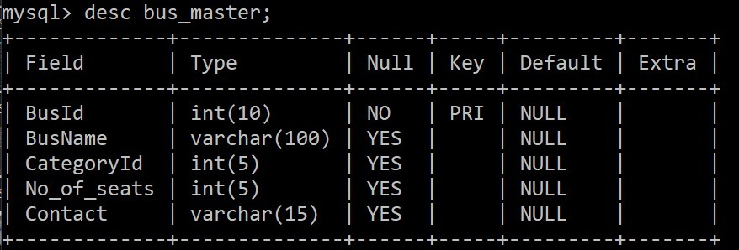

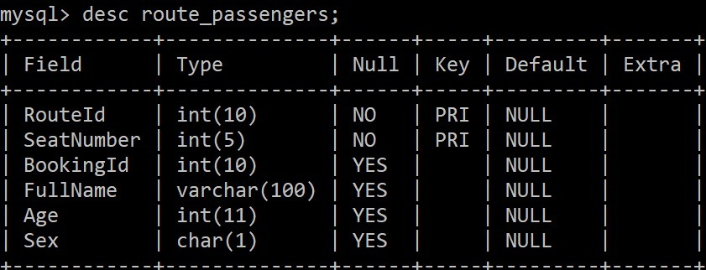

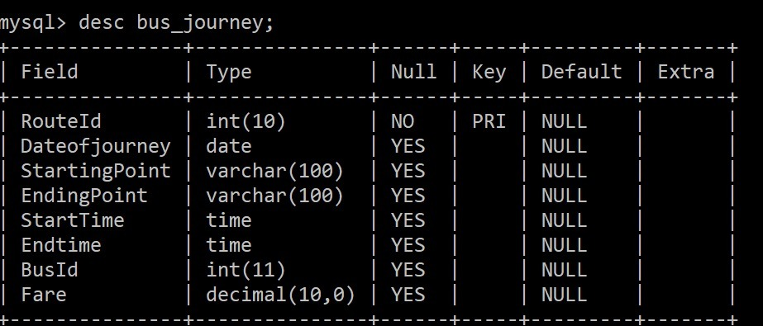

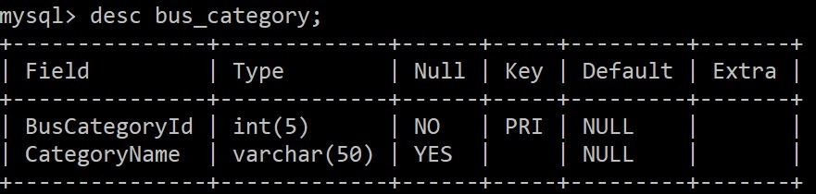

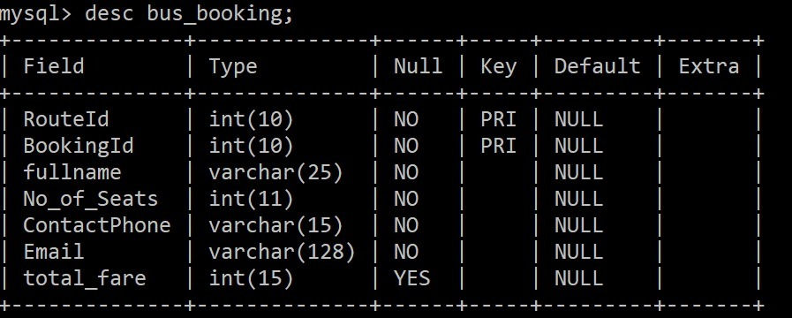

**OUTPUT**

**1.Ticket Booking**

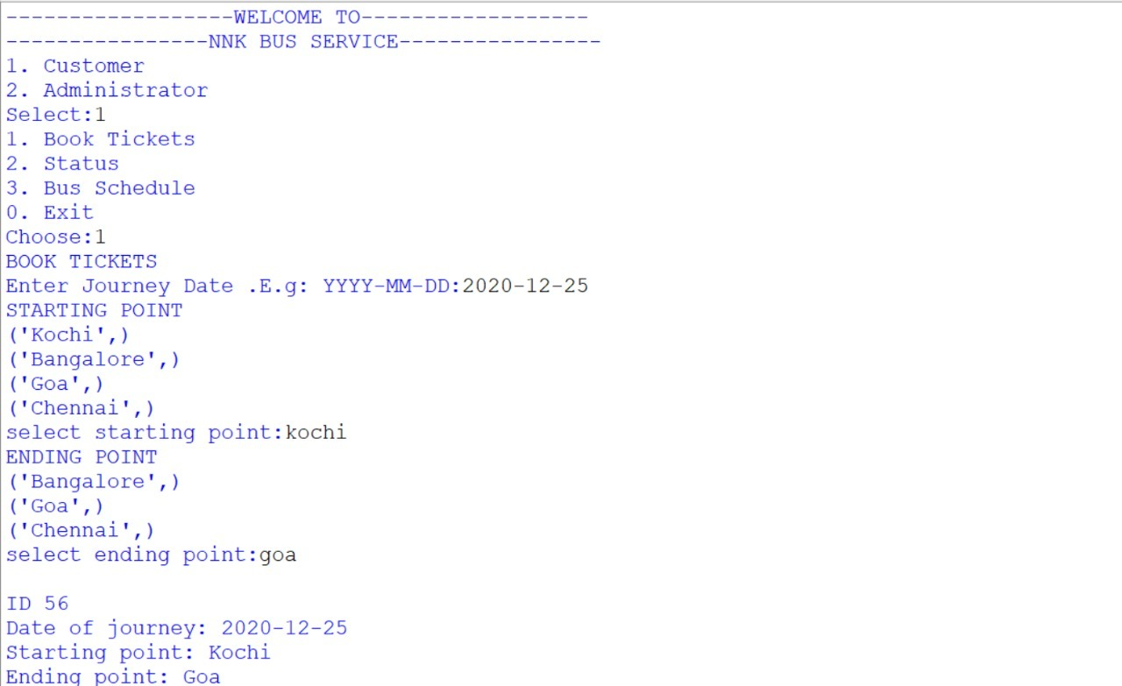

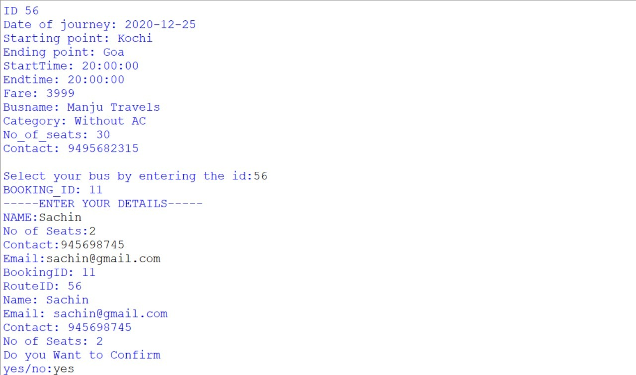

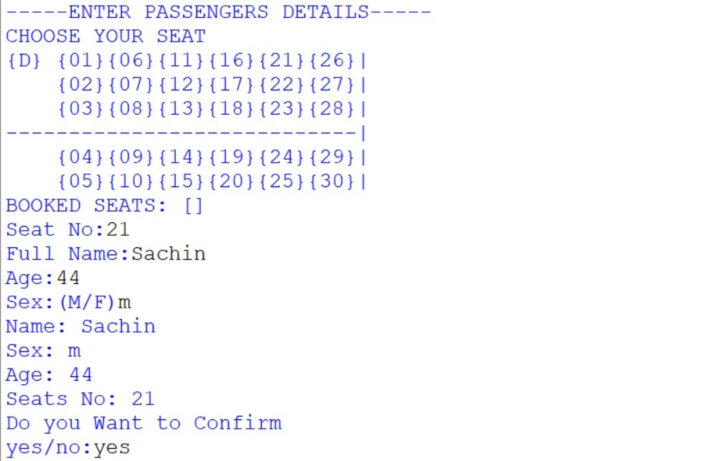

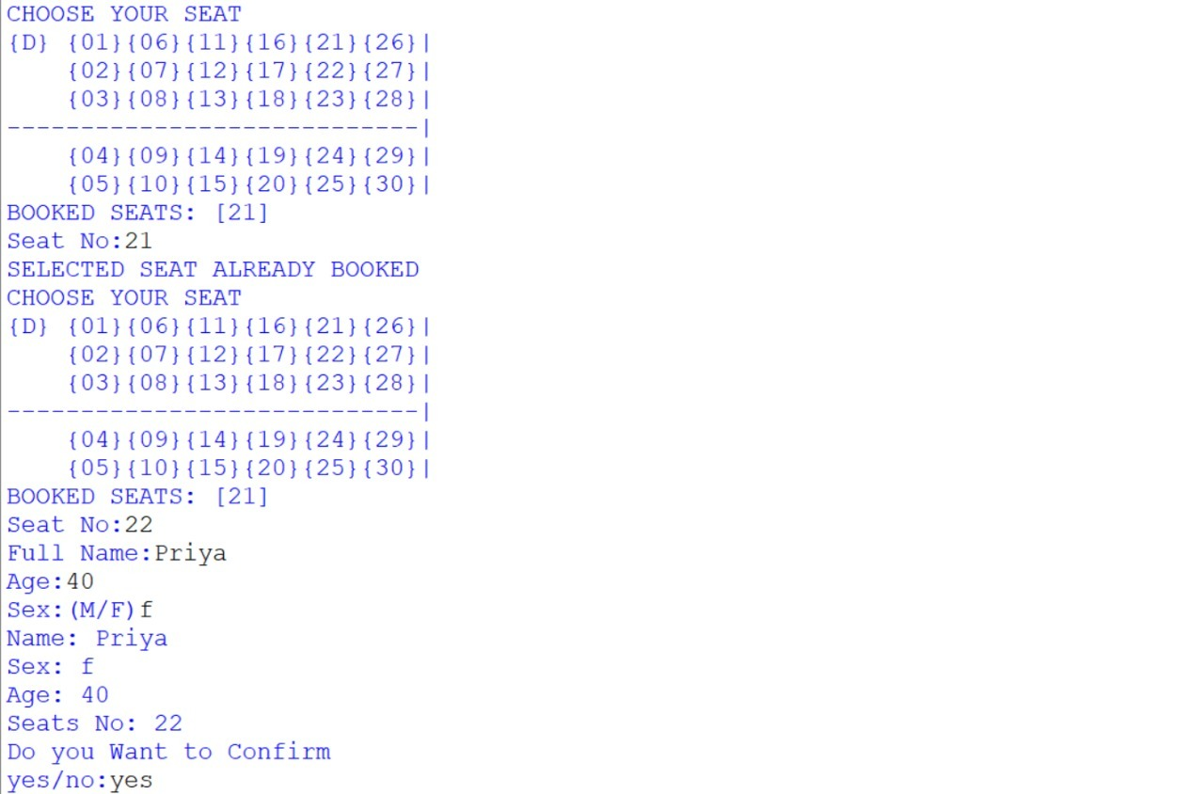

2.Ticket Status

**_______________________________________________________________________________________________________________________________**

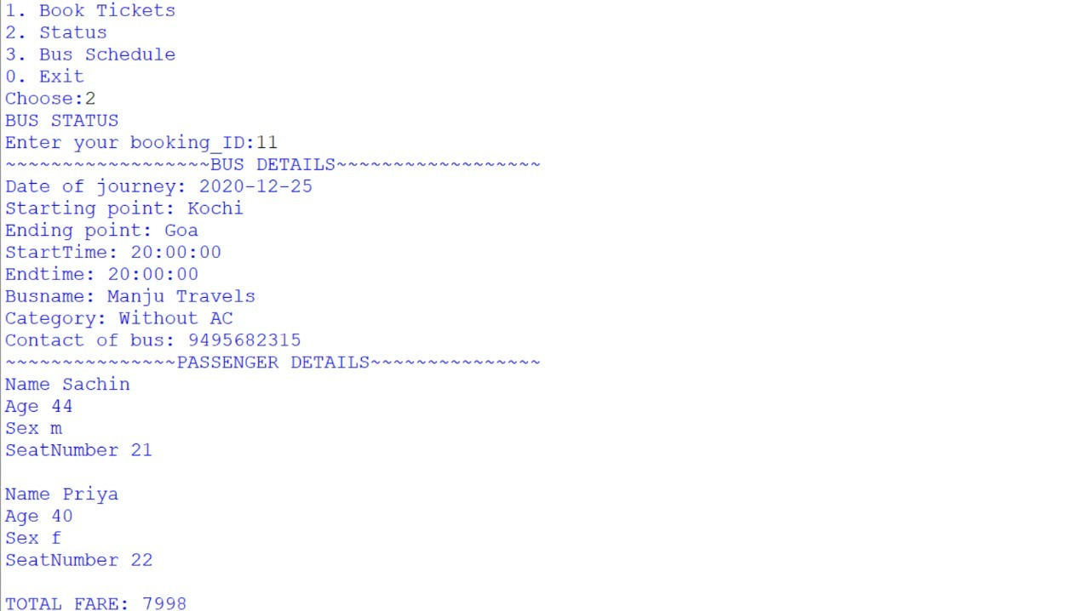

3.Bus Schedule(By source and destination)

**_______________________________________________________________________________________________________________________________**

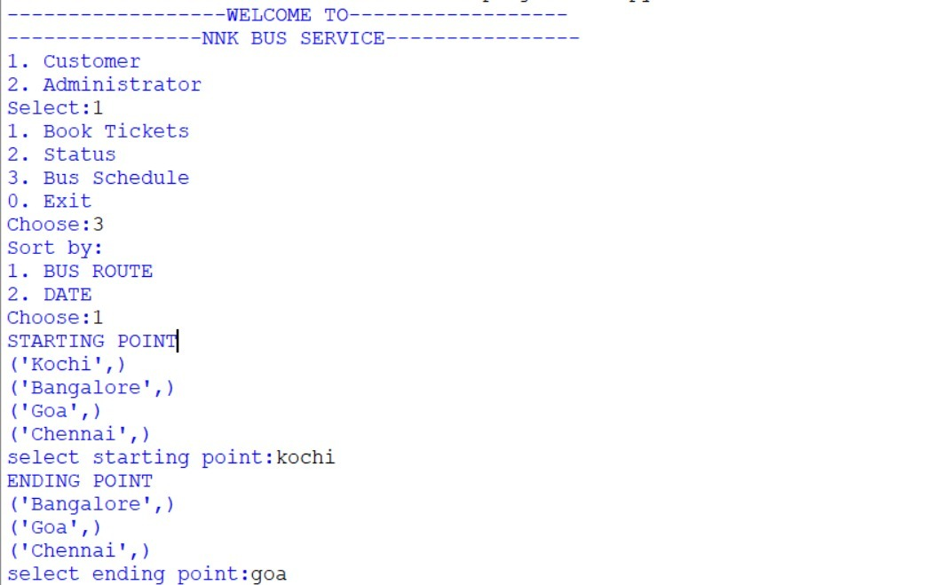

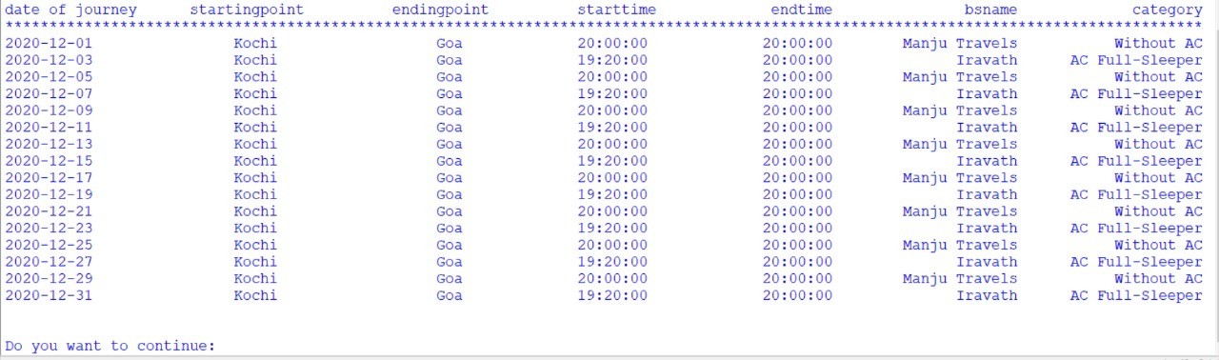

3.Bus Schedule(By date of journey)

**_______________________________________________________________________________________________________________________________**

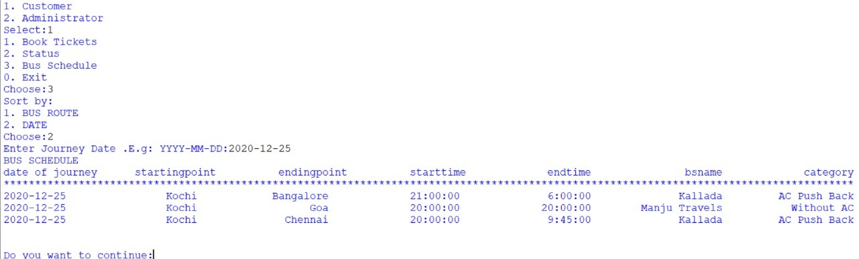

4.Reports(Passenger details)

**_______________________________________________________________________________________________________________________________**

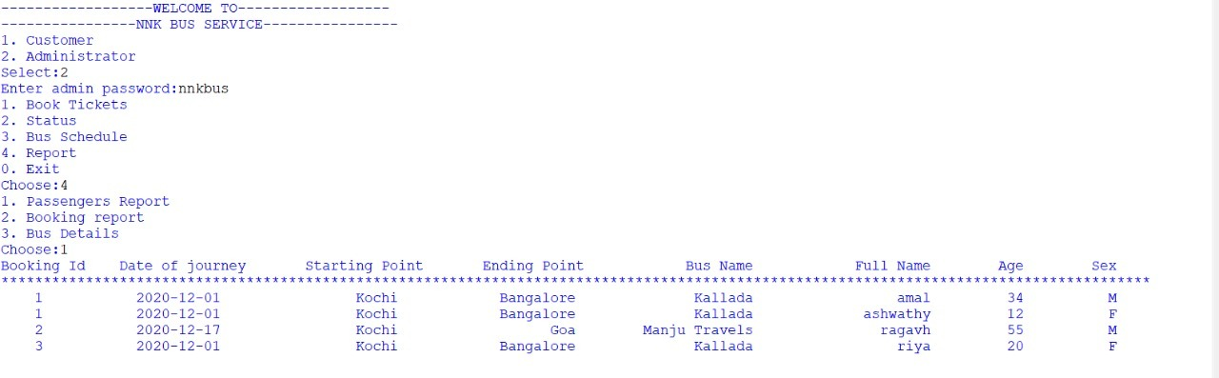

4.Reports(Booking details)

**_______________________________________________________________________________________________________________________________**

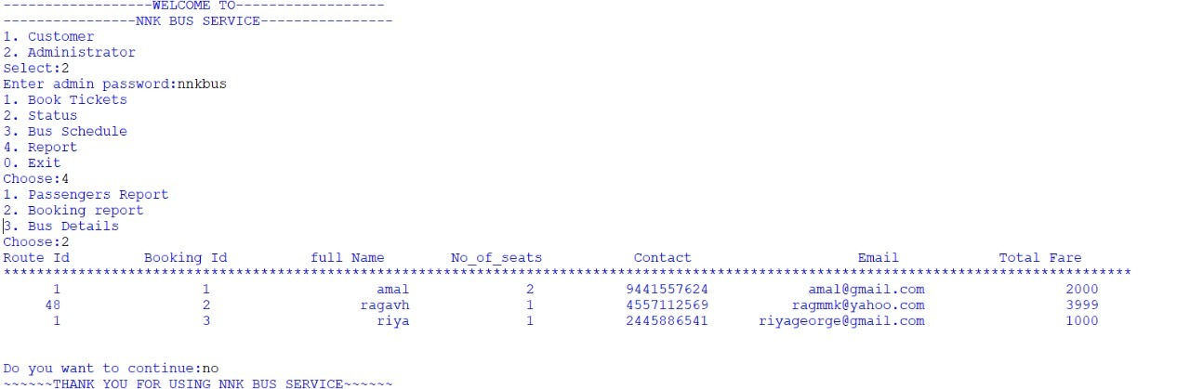

5.Reports(Bus details)

**_______________________________________________________________________________________________________________________________**

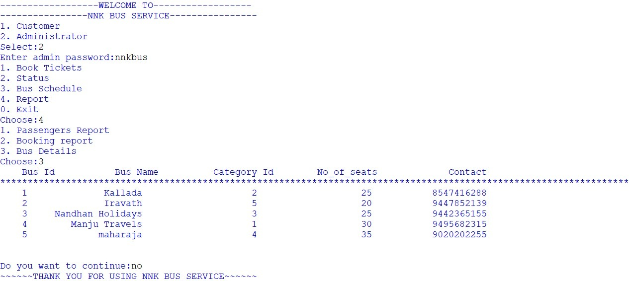

**CODE**

import mysql.connector

mydb=mysql.connector.connect(host="localhost",user="root",password="mysql",database="bus_reservation")

mycursor = mydb.cursor()

print("------------------WELCOME TO------------------")

print("----------------NNK BUS SERVICE----------------")

def user():

print('1. Customer')

print('2. Administrator')

us=int(input('Select:'))

if us==2:

pwd_re=validate_password()

if pwd_re==0:

print("YOUR ADMINISTRATOR PASSWORD IS INCORRECT \n ~~~~~Contact NNK bus service~~~~~")

return

menu(us)

def validate_password():

password=input("Enter admin password:")

if password=='nnkbus':

return 1

else:

return 0

def menu(us_type=1):

global chk

if us_type==1:

chk=1

elif us_type==2:

chk=2

print('1. Book Tickets')

print('2. Status')

print('3. Bus Schedule')

if us_type ==2:

print('4. Report')

print('0. Exit')

choice=int(input('Choose:'))

if choice==1:

book_tickets()

elif choice==2:

status()

elif choice==3:

bus_schedule()

elif choice==4 and us_type==2 :

bus_report()

else:

pass

def book_tickets():

print('BOOK TICKETS')

journeyDate=input("Enter Journey Date .E.g: YYYY-MM-DD:")

print('STARTING POINT')

start="select distinct StartingPoint from bus_journey;"

mycursor.execute(start)

myresult = mycursor.fetchall()

for x in myresult:

print(x)

startp=input('select starting point:')

print('ENDING POINT')

end="select distinct endingPoint from bus_journey where endingpoint!=%s;"

mycursor.execute(end,(startp,))

myresult = mycursor.fetchall()

for x in myresult:

print(x)

endp=input('select ending point:')

print('')

#printing the list of busses

selstartend='''SELECT routeid,dateofjourney, startingpoint, endingpoint, StartTime,Endtime,Fare,busname,categoryname,No_of_seats,Contact FROM bus_journey

INNER JOIN bus_master ON bus_journey.busid = bus_master.busid

INNER JOIN bus_category ON bus_category.buscategoryid=bus_master.categoryid

where StartingPoint=%s and endingPoint=%s and Dateofjourney=%s;'''

mycursor.execute(selstartend,(startp,endp,journeyDate,))

myresult = mycursor.fetchall()

for x in myresult:

print('ID',x[0])

print('Date of journey:',x[1])

print('Starting point:',x[2])

print('Ending point:',x[3])

print('StartTime:',x[4])

print('Endtime:',x[5])

print('Fare:',x[6])

print('Busname:',x[7])

print('Category:',x[8])

print('No_of_seats:',x[9])

print('Contact:',x[10],'\n')

if myresult==[]:

print("NO BUSES AVAILABLE IN THE PREFERRED DATE")

return

else:

#selecting bus

route=int(input("Select your bus by entering the id:"))

selbookid='SELECT IFNULL((select max(bookingid)+1 from bus_booking),1);'

mycursor.execute(selbookid)

myresult = mycursor.fetchall()

for x in myresult:

bookid=int(x[0])

print('BOOKING_ID:',bookid)

#inputing details of booking person

print("-----ENTER YOUR DETAILS-----")

confirm="no"

while confirm=="no":

myinput=()

myinput=myinput + (route,)

myinput=myinput + (bookid,)

b_name=input("NAME:")

myinput=myinput + (b_name,)

no_of_seats=int(input("No of Seats:"))

myinput=myinput + (no_of_seats,)

b_contactphone=input("Contact:")

myinput=myinput + (b_contactphone,)

b_email=input("Email:")

myinput=myinput + (b_email,)

print("BookingID:",bookid)

print("RouteID:",route)

print("Name:",b_name)

print("Email:",b_email)

print("Contact:",b_contactphone)

print("No of Seats:",no_of_seats)

print("Do you Want to Confirm")

confirm=input("yes/no:")

if confirm=='yes':

booking_input="insert into bus_booking (RouteId, BookingId, fullname, No_of_Seats, ContactPhone, Email) values(%s,%s,%s,%s,%s,%s)"

mycursor.execute(booking_input,myinput)

#inputing passenger details

print("-----ENTER PASSENGERS DETAILS-----")

for i in range(0,no_of_seats):

con='no'

while con=='no':

mypass=()

mypass=mypass + (route,)

#seat selection

mycursor.execute('''select No_of_seats from bus_master

INNER JOIN bus_journey ON bus_master.BusId=bus_journey.BusId

where routeid=%s;''',(route,))

myresult=mycursor.fetchall()

print('CHOOSE YOUR SEAT')

if myresult[0][0]==20:

print('{D} {01}{05}{09}{13}{17}|\n {02}{06}{10}{14}{18}|\n------------------------|\n {03}{07}{11}{15}{19}|\n {04}{08}{12}{16}{20}|')

elif myresult[0][0]==25:

print('{D} {01}{05}{09}{13}{17}{21}|\n {02}{06}{10}{14}{18}{22}|\n------------------------{23}|\n {03}{07}{11}{15}{19}{24}|\n {04}{08}{12}{16}{20}{25}|')

elif myresult[0][0]==30:

print('{D} {01}{06}{11}{16}{21}{26}|\n {02}{07}{12}{17}{22}{27}|\n {03}{08}{13}{18}{23}{28}|\n----------------------------|\n {04}{09}{14}{19}{24}{29}|\n {05}{10}{15}{20}{25}{30}|')

elif myresult[0][0]==35:

print('{D} {01}{06}{11}{16}{21}{26}{31}|\n {02}{07}{12}{17}{22}{27}{32}|\n {03}{08}{13}{18}{23}{28}{33}|\n--------------------------------|\n {04}{09}{14}{19}{24}{29}{34}|\n {05}{10}{15}{20}{25}{30}{35}|')

mycursor.execute('SELECT SeatNumber from route_passengers where routeid=%s;',(route,))

booked=mycursor.fetchall()

booked_seat=[]

for t in booked:

for x in t:

booked_seat.append(x)

print('BOOKED SEATS:',booked_seat )

p_seat=int(input("Seat No:"))

if p_seat in booked_seat:

print('SELECTED SEAT ALREADY BOOKED')

else:

if p_seat>myresult[0][0]:

print('ENTER VALID SEAT NO.')

else:

mypass=mypass + (p_seat,)

mypass=mypass + (bookid,)

p_name=input("Full Name:")

mypass=mypass + (p_name,)

p_age=input("Age:")

mypass=mypass + (p_age,)

p_sex=input("Sex:(M/F)")

mypass=mypass + (p_sex,)

print("Name:",p_name)

print("Sex:",p_sex)

print("Age:",p_age)

print("Seats No:",p_seat)

print("Do you Want to Confirm")

con=input("yes/no:")

if con=='yes':

pass_input="insert into route_passengers values(%s,%s,%s,%s,%s,%s)"

mycursor.execute(pass_input,mypass)

mycursor.execute('SELECT Fare FROM bus_journey where RouteId=%s;',(route,))

fare= mycursor.fetchone()

amount=no_of_seats*fare[0]

mycursor.execute("update bus_booking set total_fare=%s where BookingId=%s;",(amount,bookid))

print("TOTAL AMOUNT:",amount)

bo=input('Book tickets(yes/no):')

if bo=='yes':

mydb.commit()

#FINAL DETAILS

print("-----TRAVEL DETAILS-----")

print('BOOKING_ID:',bookid,'\n')

mycursor.execute('''SELECT dateofjourney, startingpoint, endingpoint,StartTime,Endtime,busname,categoryname FROM bus_journey

INNER JOIN bus_master ON bus_journey.busid = bus_master.busid

INNER JOIN bus_category ON bus_category.buscategoryid=bus_master.categoryid

inner join bus_booking ON bus_booking.RouteId=bus_journey.RouteId

where BookingId=%s;''',(bookid,))

myresult = mycursor.fetchall()

for x in myresult:

print('Date of journey:',x[0])

print('Starting point:',x[1])

print('Ending point:',x[2])

print('StartTime:',x[3])

print('Endtime:',x[4])

print('Busname:',x[5])

print('Category:',x[6],'\n')

print('PASSENGERS')

mycursor.execute('SELECT FullName,Age,Sex FROM route_passengers where BookingId=%s;',(bookid,))

myresult = mycursor.fetchall()

for x in myresult:

print('FullName:',x[0])

print('Age:',x[1])

print('Sex:',x[2],'\n')

print("TOTAL AMOUNT:",amount)

print('')

print('BOOKING SUCCESSFUL')

print('HAVE A SAFE AND HAPPY JOURNEY')

else:

menu(chk)

def status():

print('BUS STATUS')

bookid=int(input("Enter your booking_ID:"))

print('~~~~~~~~~~~~~~~~~~BUS DETAILS~~~~~~~~~~~~~~~~~~')

mycursor.execute('''SELECT dateofjourney, startingpoint, endingpoint,starttime,endtime,busname,categoryname,contact FROM bus_journey

INNER JOIN bus_master ON bus_journey.busid = bus_master.busid

INNER JOIN bus_category ON bus_category.buscategoryid=bus_master.categoryid

INNER JOIN bus_booking ON bus_booking.routeid=bus_journey.routeid

where bookingid=%s;''',(bookid,))

myresult=mycursor.fetchone()

print('Date of journey:',myresult[0])

print('Starting point:',myresult[1])

print('Ending point:',myresult[2])

print('StartTime:',myresult[3])

print('Endtime:',myresult[4])

print('Busname:',myresult[5])

print('Category:',myresult[6])

print('Contact of bus:',myresult[7])

print('~~~~~~~~~~~~~~~PASSENGER DETAILS~~~~~~~~~~~~~~~')

mycursor.execute('SELECT FullName, Age, Sex,SeatNumber FROM route_passengers WHERE bookingid=%s',(bookid,))

myresult=mycursor.fetchall()

for x in myresult:

print('Name',x[0])

print('Age',x[1])

print('Sex',x[2])

print('SeatNumber',x[3],'\n')

mycursor.execute('SELECT total_fare FROM bus_booking WHERE bookingid=%s',(bookid,))

myresult=mycursor.fetchone()

print('TOTAL FARE:',myresult[0])

def bus_schedule():

print("Sort by:")

print("1. BUS ROUTE")

print("2. DATE")

sch=int(input("Choose:"))

if sch==1:

print('STARTING POINT')

start="select distinct StartingPoint from bus_journey;"

mycursor.execute(start)

myresult = mycursor.fetchall()

for x in myresult:

print(x)

startp=input('select starting point:')

print('ENDING POINT')

end="select distinct endingPoint from bus_journey where endingpoint!=%s;"

mycursor.execute(end,(startp,))

myresult = mycursor.fetchall()

for x in myresult:

print(x)

endp=input('select ending point:')

print('')

print('BUS SCHEDULE')

print('--------------')

schedule ='''SELECT dateofjourney, startingpoint, endingpoint, StartTime, Endtime, busname,categoryname FROM bus_journey

INNER JOIN bus_master ON bus_journey.busid = bus_master.busid

INNER JOIN bus_category ON bus_category.buscategoryid=bus_master.categoryid

WHERE startingpoint=%s and endingpoint=%s

ORDER BY dateofjourney;'''

mycursor.execute(schedule,(startp,endp))

myresult=mycursor.fetchall()

if myresult==[]:

print("NO BUSES AVAILABLE")

else:

print('%10s'%'date of journey','%18s'%'startingpoint','%20s'%'endingpoint','%18s'%'starttime','%19s'%'endtime','%20s'%'bsname','%20s'%'category')

print("****************************************************************************************************************************************")

Lengt =len(myresult[0])

for x in myresult:

print('%10s'%x[0],'%20s'%x[1],'%20s'%x[2],'%20s'%x[3],'%20s'%x[4],'%20s'%x[5],'%20s'%x[6])

print('\n')

elif sch==2:

journeyDate=input("Enter Journey Date .E.g: YYYY-MM-DD:")

print('BUS SCHEDULE')

schedule ='''SELECT dateofjourney, startingpoint, endingpoint, StartTime, Endtime, bus_master.busname,categoryname FROM bus_journey

INNER JOIN bus_master ON bus_journey.busid = bus_master.busid

INNER JOIN bus_category ON bus_category.buscategoryid=bus_master.categoryid

WHERE dateofjourney=%s;'''

mycursor.execute(schedule,(journeyDate,))

myresult = mycursor.fetchall()

if myresult==[]:

print("NO BUSES AVAILABLE")

else:

print('%10s'%'date of journey','%18s'%'startingpoint','%20s'%'endingpoint','%18s'%'starttime','%19s'%'endtime','%20s'%'bsname','%20s'%'category')

print("****************************************************************************************************************************************")

for x in myresult:

print('%10s'%x[0],'%20s'%x[1],'%20s'%x[2],'%20s'%x[3],'%20s'%x[4],'%20s'%x[5],'%20s'%x[6])

print('\n')

def bus_report():

print('1. Passengers Report')

print('2. Booking report')

print('3. Bus Details')

cho_re=int(input("Choose:"))

if cho_re==1:

passenger_report()

elif cho_re==2:

booking_report()

elif cho_re==3:

bus_details()

def passenger_report():

mycursor.execute('''select BookingId,Dateofjourney,StartingPoint,EndingPoint,BusName,FullName,Age,Sex from bus_journey

inner join bus_master on bus_master.BusId=bus_journey.BusId

inner join route_passengers on route_passengers.RouteId=bus_journey.RouteId

order by BookingId;''')

myresult = mycursor.fetchall()

if myresult==[]:

print("NO DETAILS AVAILABLE")

else:

print('%10s'%'Booking Id','%18s'%'Date of journey','%20s'%'Starting Point','%18s'%'Ending Point','%19s'%'Bus Name','%20s'%'Full Name','%10s'%'Age','%10s'%'Sex')

print("****************************************************************************************************************************************")

for x in myresult:

print('%5s'%x[0],'%20s'%x[1],'%20s'%x[2],'%20s'%x[3],'%20s'%x[4],'%20s'%x[5],'%10s'%x[6],'%10s'%x[7])

print('\n')

def bus_details():

mycursor.execute('select * from bus_master;')

myresult = mycursor.fetchall()

if myresult==[]:

print("NO DETAILS AVAILABLE")

else:

print('%10s'%'Bus Id','%18s'%'Bus Name','%20s'%'Category Id','%18s'%'No_of_seats','%19s'%'Contact')

print("****************************************************************************************************************************************")

for x in myresult:

print('%5s'%x[0],'%20s'%x[1],'%20s'%x[2],'%20s'%x[3],'%20s'%x[4])

print('\n')

def booking_report():

mycursor.execute('select * from bus_booking ORDER BY BookingId;')

myresult = mycursor.fetchall()

if myresult==[]:

print("NO DETAILS AVAILABLE")

else:

print('%7s'%'Route Id','%18s'%'Booking Id','%18s'%'full Name','%18s'%'No_of_seats','%17s'%'Contact','%24s'%'Email','%21s'%'Total Fare')

print("****************************************************************************************************************************************")

for x in myresult:

print('%7s'%x[0],'%17s'%x[1],'%23s'%x[2],'%14s'%x[3],'%20s'%x[4],'%25s'%x[5],'%20s'%x[6])

print('\n')

user()

while True:

x=input("Do you want to continue:")

if x.lower() in('yes','y'):

menu(chk)

else:

print("~~~~~~THANK YOU FOR USING NNK BUS SERVICE~~~~~~")

break

**MITIGATION**

As this is a small school project:

* It does not have a GUI
* Payment option is not linked
* User authentication is limited to administrative login

**BIBLIOGRAPHY**

* Computer Science text (Sumitha Arora)
* python.org
* w3schools.com
* python.mykvs.in